We are going to make the greeting configurable from a config file. To the project, add an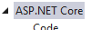 . In this file, which will be created with a connection string, add a new value pair . Now, in order to make the configuration file available in Startup.Configure, just inject IConfiguration configuration.

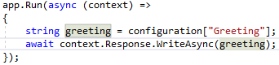
Note: when IConfiguration looks for its Greeting value, it will first choose something passed in from the command line, then it will draw from environment variables. If it doesn’t find it in either place, it looks in your appsettings file. So you can use environmental variables to override, say, the connection string in production with environmental variables.

We are going to create a custom service called Greeter that we can inject into Configure. Create an interface and class for the that we are going to inject. Then we need to register that service in Startup. . There are several possible types of ways to add the service.
services.AddSingleton – there can only be one. You will never need another
services.AddTransient – every time you need one, create it
services.AddScoped – will be created once per HTTP request

- this would give you an IGreeter, instantiated as a Greeter

How to process API requests using Middleware

Let’s say we have a request that comes in, a POST request on the reviews controller:


Each request that comes in is routed through a series of middleware, and each middleware can decide what to do with the request; send it on to other middleware, rejects it, or process it and return a response.

Now let’s imagine a middleware pipeline that we might want to run the request through:
a Logger – logs what the request was, theoretically it process or reject it (but probably not)
an Authorizer – looks for a token or other authentication. If it doesn’t get it, it rejects the request.
a Router – figures out what to do with the request. Usually it routes it to a method which returns a response. Then the response flows back through the middleware pipeline in reverse (Router to Authenticator to Logger)
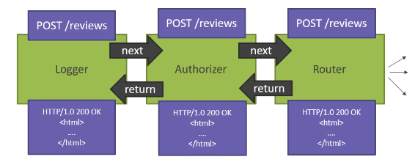

Using environment variables

In 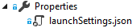, we have the setup for running under either or .

So, here is our default: 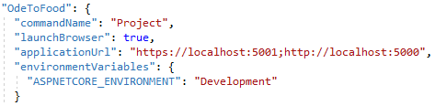

Let’s say we want to change this environment variable to production:

Then when we run it thinks the environment is production.
We can also modify these environmental information from Properties -> Debug
Now in our application we can access this information through injecting

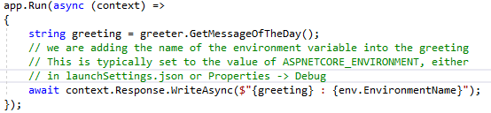

Creating an appsettings override file
Now, if we copy our appsettings.json and rename it to appsettings.Development.json, and this allows you to create a file that will override your regular appsetting file when you are in development mode.
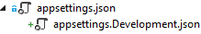

Static files (html, etc)

In order to serve up static content, you need to install middleware to handle the content, and the content pages need to be placed in the wwwroot folder.

Let’s say you have created a static index.html file in wwwroot. Now, the middleware you need is app.UseFileServer(). This allows static files to be accessed via the URL, and serves up default files for the root folder.

NuGet packages

In your project file you will find references to your packages. In your Dependencies folder you can see all your dependencies (packages).

MVC Middleware (routing)

MVC allows us to build a system where requests are analyzed, and the URL is used to send control to a “Controller”, which is a class that ends in “Controller”. MVC can figure out which endpoint (method) to send us to, using its middleware.

app.UseStaticFile() – this is the middleware that parse and routes the files. Put it in Configure()
services.AddMvc() – this is the service that supports it. Put it in ConfigureServices.

Create a /Controllers folder. This is where our controllers should go. Controller files need to end in “Controller”. The HomeController is MVC’s default controller, and if it can’t route a request to s specific controller it will try to route to Home.

The Controller is responsible for figuring out how to process and respond to the HTTP request. Often, it will construct a Model, which is responsible for holding information and business logic. Then the Controller sends that Model into a View, which is responsible for constructing HTML, which the Controller can send back in the response.

There are different methods that we can define how the middleware decides which Controller and method are called for any given HTTP request. There are three main type of routing. (see MS doc on routing)

Convention-based routing – this is defined in the Startup middleware. We create templates that the middleware matches the URL to in order to device which controller and method to send to.

Note: [Route(“users/{id:int:min(1)}”)]

View

In your controller, you can return a View(), and you get a view from /Views/<controller name>/<method name>

Add an “MVC View Page”. If it is in the Home controller, with a method named Index(), the app will look for this file:
/Views/Home/Index.cshtml

Tip: if you clear out a page and type “HTML” + <tab>, it sets you up with a basic HTML page

Models

Entity model – model that matches what is stored in the data table
View Model – contains information needed by the view (DTO – Data Transfer Object)
“output” – contains data used to display information in the view
“input” - contains

Services

Services should all be accessed through interfaces. This makes it easier to create tests, or to swap out implementations.

Snippets

ctor – contructor
html – populates a basic html page

Tag Helpers

In order to add Tag Helper support to your pages, you need to add an “MVC ViewImports” page to your /View folder. By default, this page is named “_ViewImports.cshtml”. This is the line which adds tag helper support:

@addTagHelper *, Microsoft.AspNetCore.Mvc.TagHelpers

Collecting data from a form

You need to create an endpoint which returns a page with a Form element. Use this input style for your input elements; in this way you can tie the elements to the matching properties in the model.

@model OdeToFood.Models.Restaurant
<input asp-for="Name" /> This tag helper to the input matches the Restaurant.Name property

It is good practice to create a ViewModel specifically for input purposes, which contains only those elements/properties that you expect to be populated by the form. This can prevent “overposting”, which is where a hacker uses unused elements of your model to insert values that you were not expecting.

It is good practice to create two versions of a Create (or Update), one to create the view with the form, to send to the client, and the other to receive the contents of the form submitted by the user. The one is [HttpGet] and the other [HttpPost]

Models

A View Model is a class that contains all the data that you need to render a particular page. It might have a single record or collection, but it might also contain additional lists need for pull-downs, etc.

POST – REDIRECT – GET pattern. If you do a post, you redirect to another page which sends a GET commend.

Data Annotations

Attributes that we can apply to a class to limit data entered.
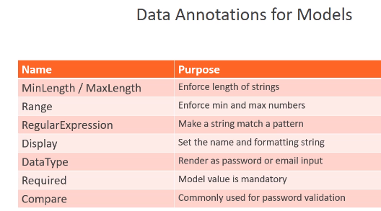

To add data annotations, find the data element in the .cshtml, highlight it, right click and select “Wrap with <div>” and add a label with asp-for=”name of property”. This causes Core to look at the model to determine the label. Then, in the model pull in System.ComponentModel.DataAnnotations. Add attributes to the properties.
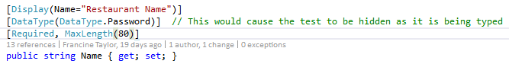

Entity Framework

How to get your developer command prompt
Open up a special command prompt for VS. Do a Windows search for “Developer Command Prompt for VS 2017”.

Some ways to view your SQL server objects

From VS Command Prompt, type “sqllocaldb info”. This will show you local server instances.

In VS, select View -> SQL Server Object Explorer (ctrl-S)
Right click on the server, select properties, at the top is the connection string
Data Source=(localdb)\MSSQLLocalDB;Initial Catalog=master;Integrated Security=True;Connect Timeout=30;Encrypt=False;TrustServerCertificate=False;ApplicationIntent=ReadWrite;MultiSubnetFailover=False

To install dotnet ef (an Entity Framework command line utility)

Put this in your project:
<ItemGroup>
<DotNetCliToolReference Include="Microsoft.EntityFrameworkCore.Tools.DotNet"
Version="2.0.0"></DotNetCliToolReference>
</ItemGroup>
In your developer prompt, type “dotnet ef” to get your options

Some dotnet ef commands that you can type in the VS command window
“dotnet ef dbcontext list” – see all the DbContext classes that I have in my project
“dotnet ef dbcontext info” – see additional information about those Dbcontexts (data source,
“dotnet ef migrations add -–help” – see migration options
“dotnet ef migrations add InitialCreate -v” – create a migration class in /Migrations
“dotnet ef migrations remove” – gets rid of migrations classes
“dotnet ef database --help” – see database options
“dotnet ef database update -v” – updates/creates the database to the latest migration

Razor Views

Layout views

Generally, on every page you have a logo and a navigational menu, a sidebar with additional links and probably a footer at the bottom with some small print and maybe more menu choices.

A “layout view” is a view which is used to make sure your pages are uniform, containing code that will be common across multiple pages. A common convention has these pages starting with an underline, for example, _Layout.cshtml. Normal controller view pages are set up to render inside a layout view, so that the normal views don’t need to know anything about navigation or menus; they are only required to render their specific content.

Put layout pages in a /Shared folder inside the /Views folder. To add a layout page, add a “Razor Layout” item. Since we are going to be using the layout page to contain the html and body tags, we can remove them from all content pages.

Note: pressing <ctrl>k, <ctrl>d will reformat an html page

If MVC finds a file named “_ViewStart.cshtml”, it will execute this code before executing code inside any other view. This allows up to remove duplicate code from our other views. If you place your _ViewStart page in the /Views folder, it will execute for all views. If you place it in the /Home folder it will execute for all Home views. It is overrideable, in individual files and in specific folders (code in the /Home folder will override code in the /Views folder)

“_ViewImports.cshtml” is another special file for MVC. It allows you to add namespaces and taghelpers to all files. It is hierarchical, so you can override and restrict depending on which folder you put it in.

Razor Pages

Razor pages are .cshtml files that can be called directly, and don’t have to be called from a controller. They live in a folder named /Pages. The name is significant, because it will be part of the route that calls it. Create one with “New Item” => “Razor Page”. Razor Pages can use _ViewImport and _ViewStart.

A razor page’s model is the class that is the code-behind for the page, and it inherits from PageModel.

